PARENT & CARER ONLINE SAFETY AWARENESS SESSION
DO YOU REALLY KNOW WHAT
YOUR CHILD IS DOING ONLINE?

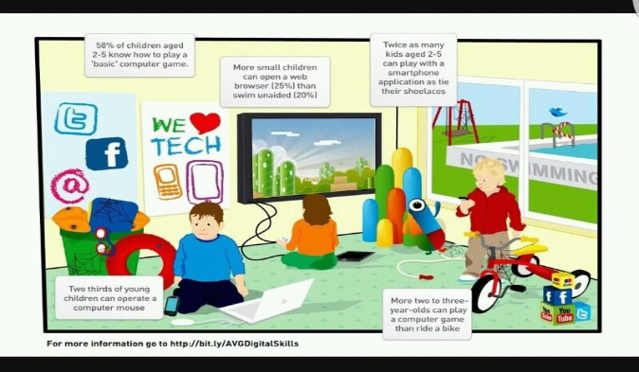

70%
of 8 – 17-year old’s have seen images and videos not suitable for their age ONLINE.

DO YOU KNOW WHO

YOUR CHILD’S ONLINE

FRIENDS ARE?

1 IN 3
CHILDREN HAVE BEEN A
VICTIM OF CYBERBULLYING

TOPICS INCLUDE

CURRENT INTERNET

SAFETY CONCERNS
VIRTUAL REALITY & GAMING
PRACTICAL TIPS
SOCIAL MEDIA APPS
AND SITES

DATE:
TIME: LOCATION:
R E P L Y S L I P
I/WE (PLEASE INDICATE HOW MANY __________) WILL BE ATTENDING THE PARENTS’ ONLINE SAFETY SESSION
NAME:
NAME OF CHILD :
CLASS:

